# Coursera Capstone Project

THE BATTLE OF NEIGHBORHOODS

INTRODUCTION :

With an estimated population of 8,622,698 , NEW YORK is the most densely populated city in the United States.

New York city consists of 5 Boroughs and each borough has many Neighborhoods. New York City are well known, with the city having

three of the world's 10 most visited tourist attractions in 2013 and receiving a record 62.8 million tourists in 2017.

The 5 Boroughs are :

1. Manhattan
2. Brooklyn
3. Queens
4. The Bronx
5. Staten Island

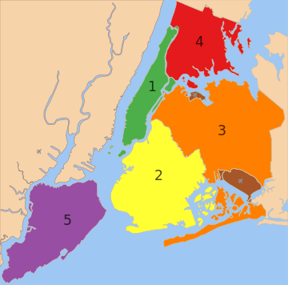

5 Boroughs of New York

New York City's food culture includes an array of international cuisines influenced by the city's immigrant history.

Italian immigrants brought New York- style pizza and Italian cuisine into the city, while Jewish immigrants and Irish immigrants

brought pastrami and corned beef, respectively.Chinese and other Asian restaurants,sandwich joints,trattorias,diners , and coffeehouses

are ubiquitous throughout the city. Some 4,000 mobile food vendors licensed by the city, many immigrant-owned, have made Middle

Eastern foods such as falafel and kebabs examples of modern New York street food. The city is home to "nearly one thousand of the finest

and most diverse haute cuisine restaurants in the world", according to Michelin. The New York City Department of Health and Mental Hygiene

assigns letter grades to the city's 24,000 restaurants based upon their inspection results.

The mission of this project is to use Foursquare location data and regional clustering of venue information to determine which Neighborhoods are

good for specific type of restaurants for some specific cuisines and has many restaurants of that particular cuisines in that neighborhood.

Because New York is a great attraction for tourists, different tourists like different cuisines. This data will help the Govt and people in this

business , to determine the cuisines in demand in different neighborhoods ,which in turn helps them to shape and grow their business.